**Optimal inventory estimation of a nightclub applying the Newsvendor Model**

*Rengifo Campo, Nicolás (1) ; Madrid Peláez, Juan Pablo(1); Cardeño Luján , Salomón(1) Laniado Rodas, Henry(2). (1) Mathematical Engineering students. (2) Probability Theory Professor. Eafit University. 2019-1.*

This article consists in the application of a mathematical model used to determine the optimal inventory levels for a nightclub. The model in case is the Newsvendor Model, in which the classical mathematical structure will be taken into consideration and then put in context for said nightclub. The resulting objective function will be minimized under specified considerations thus presenting the optimal inventory function. Historical data of certain products is then used to determine the statistical distributions that fits the data and then, optimal inventory is estimated.

*Keywords:* optimal inventory; Newsvendor Model; statistical distribution.

1. **Introduction**

The Newsvendor Model is a well known model for operations management and operations research that has been in the literature for around 131 years, making its first (known) appearance in a 1888 Journal of the Royal Statistical Society’s article called “*The mathematical theory of banking”* by Francis Y. Edgeworth, an irish economist and statistician (1845-1926) who applied mathematics to the fields of economics and statistics in a innovatively manner [1]. It has made appearances ever since all over this fields like in Econometrica’s “*Optimal Inventory Policy”* (1951) [2] and also because of its versatility, it has evolved and been used to this day.

To understand the Newsvendor Model, we need first to state its objective, that is: to find the optimal stock or inventory level that minimizes the overstock and understock costs, given that the demand distribution and cost parameters are known. And second, to state its characteristics or assumptions: it is a 1 period decision model (given that the objective is to make a decision for a certain period of time); its demand is stochastic and with uncertainty; the non sold articles (due to overstocking) will have less or no value at the end of the period; and finally, the unsatisfied demand (due to understocking) will present penalties.

It is key to notice how this business structure characteristics can be found in many contexts like buying seasonal goods to a provider, making a decision in a last production cycle, deciding optimal stock levels, selecting the optimal capacity for a machine or a facility, or even deciding the optimal booking or reservation quantity, etc.

The same can be said about the mathematical structure, in which, all of the business contexts mentioned before share: a decision variable (decision quantity), demand with uncertainty (aleatory variable with a statistical distribution), unitary overstock and understock costs. Classically defined as Q, D, Co, Cu respectively.

1. **The Newsvendor Model**

Let us consider the case when instead of a 'newsvendor' we have in fact a small company. This company has the characteristic of wanting to produce goods to an uncertain market. We can formulate the cost function of this more general situation (i.e. a company, instead of a newsvendor) in the following manner:



 (1)

Where $D$ is a random variable with probability distribution $F$ representing uncertain customer demand, $C_{f}$ is a fixed cost of production of the company, each product production costs $C_{v}$, $q$ is the product quantity in the inventory, the initial inventory level is represented by $x$, $p$ is a back order cost (penalty cost of unsatisfied orders), h is a cost of inventory and stock holding.

Note that $E[max(D-q,0)]$, the difference between demand and quantity in the inventory, denotes the expected storage quantity, and $E[max(q-D,0)]$ is the expected product quantity in stock at the end of the period.

Our objective is to minimize the cost function ($(1)$) to maximize earns

Applying the definition of expected value in (1),

(2)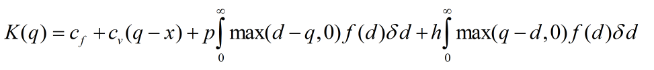

In the first integral in (2), the function $max(d-q,0)$ works as a condition, it doesn't take the negative values of $d-q$, the solution will be 0 for $d≤q$, in the second integral the opposite. We will obtain the same result changing the integration limits:

(3)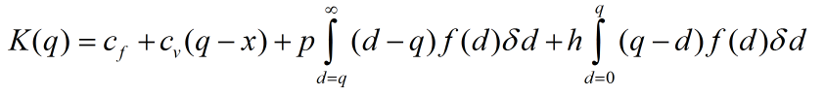

The previous step will help us to understand the function. We proceed to separate both integrals, treating $q$ as constant,

 



(4)

Using the definition of $F$ in (4),

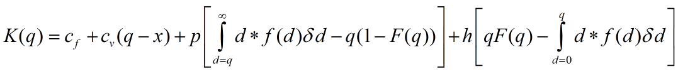 

(5)

Now we proceed to derive in (4) to later equal to 0, obtaining a sum of derivatives,

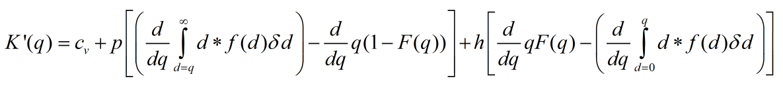



 (6)

Note that $\int_{q}^{∞}{}df(d)dd=μ-\int_{0}^{q}{}df(d)dd$, deriving both sides and applying the fundamental theorem of calculus, $\frac{d}{dq}\int_{q}^{∞}{}df(d)dd=0-\frac{d}{dq}\int_{0}^{q}{}df(d)dd=-qf(q)$, therefore,





(7)

We obtain,



 (8)

Note that $K(q)$ is convex for all q values:

 (9)

Equaling (8) to 0 to find $q_{opt}$ (the $q$ that minimize the costs),

 (10)

Obtaining,

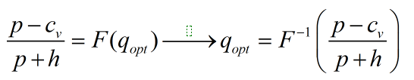 (11)

Therefore, to calculate the amount of inventory that the company must have, knowing $F, p, c_{v}, h$, we use the following formula,



. (12)

1. **The nightclub: historical data and simulation**

We will be centered on a nightclub located in the Popayán city where a sales follow-up for 33 products was made for each weekend from March of 2016 to January of 2019, therefore having a total of 174 weeks’ worth of historical data. We will emphasize solely in the water bottle.

The water bottle historical data was then imported to the Stat::Fit plugin for SIMUL8, that is, all the corresponding data for the water bottle sales during all of the weeks in question; and the results are shown below:

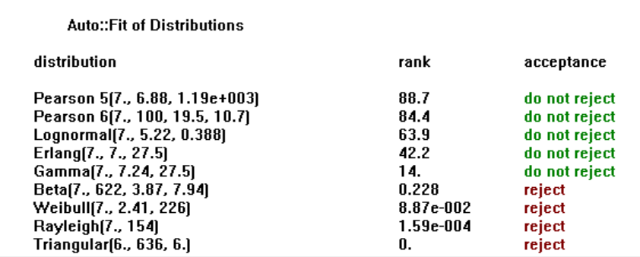

**Figure 1.** Water bottle estimated statistical distribution.

Because of the ranking shown in the results we proceed to select from the top three distributions, from which we utilize the Lognormal distribution [4] approximation for mathematical simplicity. The parameters for said distribution are shown in the figure below:

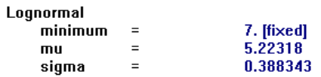

**Figure 2.** Lognormal distribution approximation parameters.

Once the parameters are obtained, we will be using the inverse distribution function from Microsoft Excel to find the optimal inventory and then equation (12). The results are as follow:



  
**Figure 3.** Inverse distribution function used in Microsoft Excel (top) and results (bottom).

Therefore, we interpret this result as follow: the estimated optimal inventory value is 176 water bottles per each weekend.

1. **Conclusions**

Based in the results its shown that, firstly, it is possible to successfully make an estimate of the optimal inventory applying the Newsvendor Model that maximizes utilities in a period of time. Secondly, the approach taken may give us a concise result, but it certainly lacks if we decide to make an estimate in a larger period and also if the statistical distribution that fit the historical data of a certain product implies harder mathematical efforts to find an inverse function. That being said, the potential is representative enough as to open the possibilities for improvements like increasing the time period (given the considerable amount of historical data) and also modelling more products if possible.

1. **References**

**[1]** Edgeworth, F.Y. (1888). “The Mathematical Theory of Banking”, Journal of the Royal Statistical Society, 53, 113-127.

**[2]** Arrow, K., T. Harris, and J. Marschak (1951). “Optimal Inventory Policy”, Econometrica, 19 (3) 250-272.

**[3]** Yong Wang, (2017, May 24). Operations Research 14D: Newsvendor Inventory Model [Video]. Retrieved from https://www.youtube.com/watch?v=FTmrUbP5kq0

**[4]** Johnson, Norman L.; Kotz, Samuel; Balakrishnan, N. (1994), "14: Lognormal Distributions", Continuous univariate distributions. Vol. 1, Wiley Series in Probability and Mathematical Statistics: Applied Probability and Statistics (2nd ed.), New York: John Wiley & Sons, ISBN 978-0-471-58495-7, MR 129997

**[5]** John D. Cook (Oct 3, 2008). "Inverse Gamma Distribution" (PDF). Retrieved 3 Dec 2018